Nick Forleo

SWENG 505

**Portfolio 2**

After reading the distinctions between a manager and a leader that were made by Kotter and Bennis I think that I would make a better leader than a manager. I happened to have the opportunity this summer to fulfill a leadership/managerial role leading eight interns. I mention this because this experience made me feel closer to being a better leader than manager, which aligns with Kotter and Bennis’ distinctions.

Some manager distinctions that I feel I didn’t quite live up to were promoting efficiency, doing things right, coping with complexity, planning and budgeting, organization and staff allocations, and controlling and problem solving. In hindsight, I should have reached out to the intern group more in the beginning. We only set up once-weekly meetings and for the first three or four weeks, the interns were asking a lot of basic questions that let me know they were not making a lot of progress during the week. They were not working or spending their time efficiently. I often did not “do things right” when it came to organizing and staffing. I didn’t do well with keeping our JIRA board tickets up to date which made status tracking difficult when I was looking at what still needs to be done. I also over allocated the interns. Originally only six out of the eight were supposed to work on my project, but I ended up assigning work to the others and absorbing them on my project early on which meant I had to continue to find tasking for them. This, in turn, meant that the budgeting for the intern program had to be slightly adjusted. I also didn’t control the group’s direct work and let them (for the most part) decide where they wanted the project to go. After reflecting on this experience, I have definitely identified opportunities to improve my management skill set.

I feel that I was a much better leader because I was more aligned with the leader distinctions. I promoted effectiveness by aligning the intern’s skills with the tasking demands. I also assigned people to specific pieces of the project that they showed interest in so that they were motivated to do a good job. I challenged the interns by setting a direction and allowing them to find a path to the solution, rather than micromanaging their process. When they hit roadblocks, I worked with the group to find alternative solutions or to adjust the project outcome to be more realistic. I believe that the combination of these aspects meant I was doing the right things, not following a specific plan laid out by my boss. I lead in my own style that allowed me to come up with project goals as we made progress and allowed for the interns to come with and achieve some of their own project goals.

While I believe that I make a better leader than a manager, there is still room improvement for both skills. I think I would be more effective if these skills were closer to each other.

**Portfolio 3**

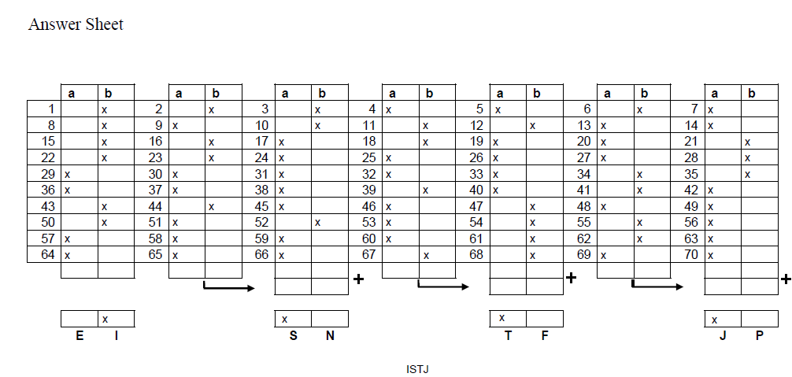

**Portfolio 4**

1. 2 Team members are passionate and unguarded in their discussion of issues.

Most of the time this is true. However, I do come come across some team members more often then I would like that do not see interested in succeeding

2. 1 Team members call out one another's deficiencies or unproductive behaviors.

There have been times were I wish I would call out poor performance or time wasting, but I also find that most of the time, my project lead doers not do this which puts me in an uncomfortable spot

3. 3 Team members know what their peers are working on and how they contribute

to the collective good of the team.

Usually everyone is contributing to a meaningful piece of the project

4. 3 Team members quickly and genuinely apologize to one another when they say

or do something inappropriate or possibly damaging to the team.

I don’t think I’ve worked with anyone who was not self aware enough to realize when they misspoke when collaborating.

5. 2 Team members willingly make sacrifices (such as budget, turf, head count) in

their departments or areas of expertise for the good of the team.

6. 2 Team members openly admit their weaknesses and mistakes.

I try to do this as often as possible and some of my favorite colleagues also do, but there are also plenty of others who take on tasking knowing they don’t know what they are doing

7. 1 Team meetings are compelling, and not boring.

Most team meetings that are more than 15 - 30 minutes are a waste of time. People spend a lot of time off topic or having a lengthy discussion with an individual, essentially holding everyone hostage

8. 3 Team members leave meetings confident that their peers are completely

committed to the decisions that were agreed on, even if there was initial

disagreement.

9. 3 Morale is significantly affected by the failure to achieve team goals.

The project I am working on now struggled for a while when we could not a agree on a solution to a problem

10. 3 During team meetings, the most important and difficult issues are put on the

table to be resolved.

My experience in this project is that if there is a difficult issue, it is usually addressed asap in the meeting

11. 1 Team members are deeply concerned about the prospect of letting down

their peers.

I feel like I am the only person on my projects that has this concern when facing difficult tasking

12. 2 Team members know about one another's personalities and are comfortable

discussing them.

13. 3 Team members end discussions with clear and specific resolutions and calls

to action.

14. 3 Team members challenge one another about their plans and approaches.

15. 3 Team members are slow to seek credit for their own contributions, but quick

to point out those of others.

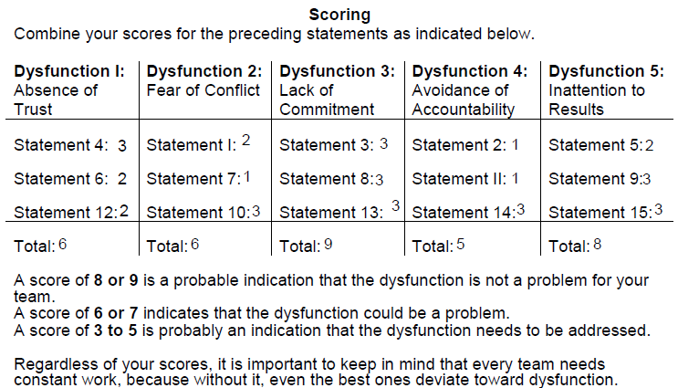

Initially, after getting the totals for each Dysfunction, they all make sense.

*Dysfunction 1: Absence of Trust*

I absolutely do not trust some of my colleagues to reach certain deadlines or even get the work done at all. There have been plenty of times where this work falls back on me.

*Dysfunction 2: Fear of Conflict*

I certainly am conflict averse. I don’t want to bring attention to problems, especially if I know my boss will have a different opinion on it (specifically when it comes to personnel issues). My boss, also, is too nice sometimes. He always give someone the benefit of the doubt, which is nice, but it often comes at the expense of getting actual work done.

*Dysfunction 3: Lack of Commitment*

I don’t think that anyone on the team has a lack of commitment. Everyone wants to and is working towards a common goal.

*Dysfunction 4: Inattention to Results*

We also do not have this issue. Although I think the reason is because I tend to pick up the slack when my colleagues do not provide enough. Unfortunately, this happens too often, but we do get the results needed for a win.